**SOP – Remote Firmware Update for the GMRT Rabbit MCM Cards**

**Rahul D. Bhor , J. Kodilkar, S. Nayak** $ 30/06/2015 Version 1.0 $

**Amol Chavan , J. Kodilkar, S. Nayak** $ Version 2.0 – Program re-installed after PC Crash $

**J. Kodilkar, S. Nayak** $ Version 3.0 – New Facility to load program from Linux Machine $

1. **Introduction:**

This document describes how to enable and update the firmware remotely on the Rabbit RCM 4300 Series cards. The firmware written for various GMRT sub-systems like Front-end, FPS, Optical-Fiber and GMRT Analog Backend (GAB) systems can be updated over Ethernet Interface using the Web-browser based Application. The SOP described here explains the required steps to enable and update the firmware on Rabbit MCM cards.

There are two different versions of this software to update the firmware remotely:

1. Firmware update on single MCM card (v1.0)
2. Firmware update on multiple MCM cards (v2.0)
   1. **Pre-requirements:**

To enable the remote firmware update feature, user should have:

* Fair knowledge of Dynamic C programming language and Rabbit Core Modules.
* ***Dynamic C v10.54*** IDEor later installed on windows PC.
* ***Application program files*** to be updated on the Rabbit Core Module (RCM4300 or later).
* Application Program must have Modules to communicate over Ethernet using the TCP/IP.
* Working Ethernet connection to the MCM cards.
* Download ‘***firmware\_update.c’***, ‘***upload.zhtml****’* and *‘****Up\_Sum.xml****’* files[[1]](#footnote-1).
* Access to the server running on machine ***rcmwork*** (IP: 192.168.8.253).
* All files mentioned above must be saved in same directory.

**2. Steps to Enable the Rabbit MCM card for Remote firmware update:**

Steps mentioned in this section requires only first time to enable the Rabbit card for remote firmware updating over the RJ45 Ethernet Interface. Therefore, after compilation of the application program along with the files required for remote update, firmware shall be updated over the USB/Serial Programming cable.

1. Add *‘firmware\_update.c’* file at the beginning of main application program using following syntax :

***#include "firmware\_update.c"***

1. Add following lines in RESOURCETABLE written in main application program

***SSPEC\_RESOURCE\_FUNCTION("/", root\_htm),***

***SSPEC\_RESOURCE\_XMEMFILE("/fw/upload.zhtml", upload\_zhtml),***

***SSPEC\_RESOURCE\_P\_CGI("/fw/upload.cgi", firmware\_upload,***

***REALM, ADMIN\_GROUP, 0x0000, SERVER\_HTTP, SERVER\_AUTH\_DIGEST)***

1. To assign the new or change the IP address and network settings, declare following variables in an application header file.

***#define MY\_IP\_ADDR*** *"xxx.xxx.xxx.xxx"*

***#define MY\_GATEWAY*** *"xxx.xxx.xxx.xxx"*

***#define MY\_NET\_MASK*** *"255.255.255.0"*

1. At the beginning of application program, in main( ) function, call ***fwinit( )*** function.

This function will check and verify the currently running and secondary firmware present on that card and will update the information about these firmware.

1. Define following global macros in Dynamic-C IDE, using the menu

***Options*** 🡪 ***Project Options*** 🡪 ***Defines tab***

***\_FIRMWARE\_NAME\_="GAB MCM"***

***\_FIRMWARE\_VERSION\_=0x0101***

***ADMIN\_USER="user"***

***ADMIN\_PASS="password"***

**Note:** Make changes in above definitions as per your requirements.

1. Now compile and store application program in target device flash memory using the USB/Serial Programming cable.

**3. Remote Firmware Update on Single MCM Card (v1.0):**

Procedure mentioned in this section assumes that the Rabbit MCM card is already enabled for the remote firmware updating (refer ***section 2*, steps *a* to *e***). To update the firmware remotely over Ethernet interface, follow the procedure given below:

1. In Dynamic-C IDE, compile the project enabled for remote firmware update to generate **.bin** file (refer ***section 2*, steps *a* to e**).
2. Open web browser in any PC connected to the LAN.
3. Enter IP Address of the Rabbit MCM card which we need to update remotely.

For example: ***http://192.168.30.2/fw/upload.zhtml***

1. After providing valid authentication details, you will see the web page based user interface as shown in ***figure 1***.
2. It will show current firmware running on that MCM card and last firmware uploaded along with the date and time.
3. To upload new firmware file click on ***Browse*** button. Go to the directory where **.bin** file of new firmware is placed. Select it and click on ***Upload*** button.
4. It will upload this file to the server running on MCM card. Then uploaded firmware name and size in Kbytes will be displayed as shown in ***figure 2***.
5. Then click on ***Install*** button to install this firmware.
6. MCM card will store it in flash memory, install it and reboot automatically with the new firmware if it is not corrupted. In case of remote firmware update procedure could not complete successfully, old application firmware will retain as it is.

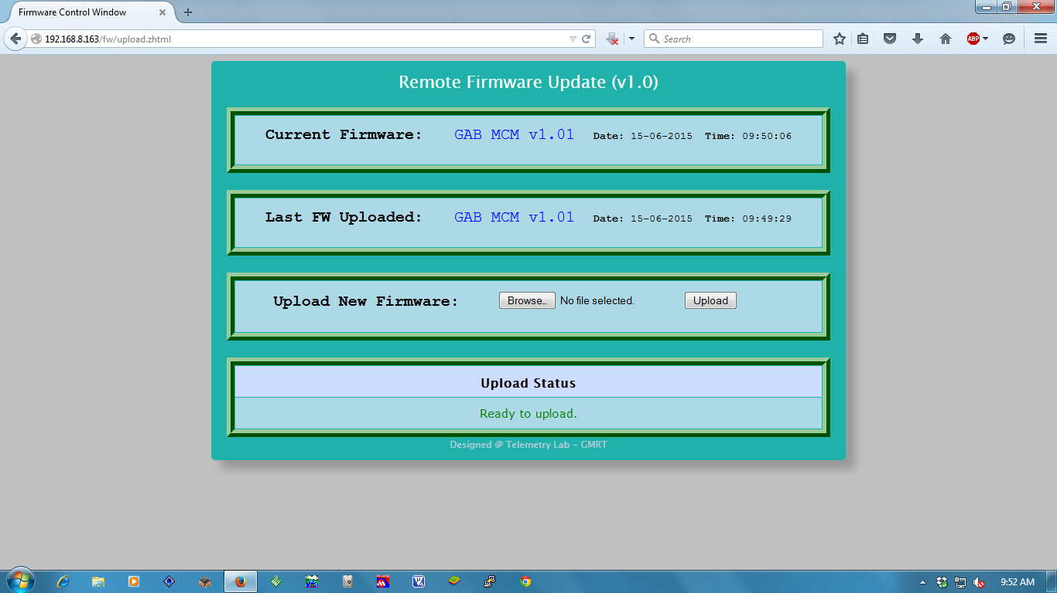

Figure 1: Webpage for Remote Firmware Update on single MCM card.

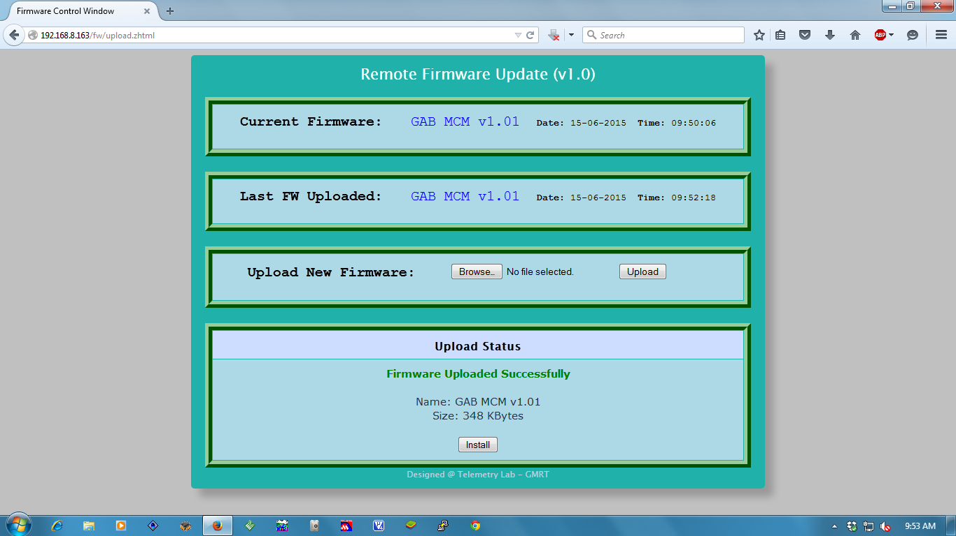

Step1: Enter IP address

Step3: Install Firmware

Step2: Upload Firmware

Figure 2. : Webpage with upload status.

**3.1 Remote firmware update on Multiple MCM cards (v2.0):**

Procedure mentioned in this section assumes that the Rabbit MCM card is already enabled for the remote firmware updating (refer ***section 2*, steps *a* to *e***). To update the firmware of multiple MCM cards, procedure given as follows:

1. In the application program, comment the network settings mentioned in section 2 under item ‘c’ and compile to generate ***.bin*** file to use it for all MCM cards.
2. Enter the remote firmware update server’s URL ***http//:rcmwork*** or IP address ***192.168.8.253*** in a web-browser. It will show the home page of the server as shown in ***figure 3.0****.*
3. Select the sub-system and antennas from the ‘***Select Target Device’*** section.
4. Click on ***CONNECT*** button to check the status of selected devices. The status will appear in ‘***Firmware Status’*** section where version of currently running firmware and firmware stored in secondary flash memory of MCM card will be shown along with the date and time (as shown in ***figure 3.1)***. If the server could not connect to the device, such message will be displayed in red color along with the antenna name and MCM card IP address. For the MCM cards which are not accessible, firmware will not be updated.
5. Using ***Browse*** button, select the pre-compiled ***.bin*** file and upload it to the ***rcmwork*** ***server*** using the ***Upload*** button. On successful upload, firmware name and size will appear in ‘***Upload Status***’ section where ***Install*** button will be displayed (as shown in ***figure 3.1***). Otherwise relevant error message will appear.
6. Click on the ***Install*** button. Firmware uploaded on the rcmwork server will be download by the individual selected MCM cards and will be installed automatically. The process of download and installing will be indicated by the progress bar (as shown in ***figure 3.2***). Upon completion of the process, Installation Status for these MCM cards will appear in ‘***Firmware Status’*** section where green tick mark (C:\Users\RAHUL\Desktop\New folder\New folder (2)\check-157822_640.png) will indicate successful installation and red-cross mark (C:\Users\RAHUL\Desktop\New folder\New folder (2)\12065738771352376078Arnoud999_Right_or_wrong_5.svg.hi.png) will indicate the failure.

**NOTE:** (i) Status button can be clicked any time to see the status of last update process for selected devices.

(ii) For detailed information about the page, click on ***Help*** button.

(iii) ***Reset*** button will reset the webpage and not the selected devices.

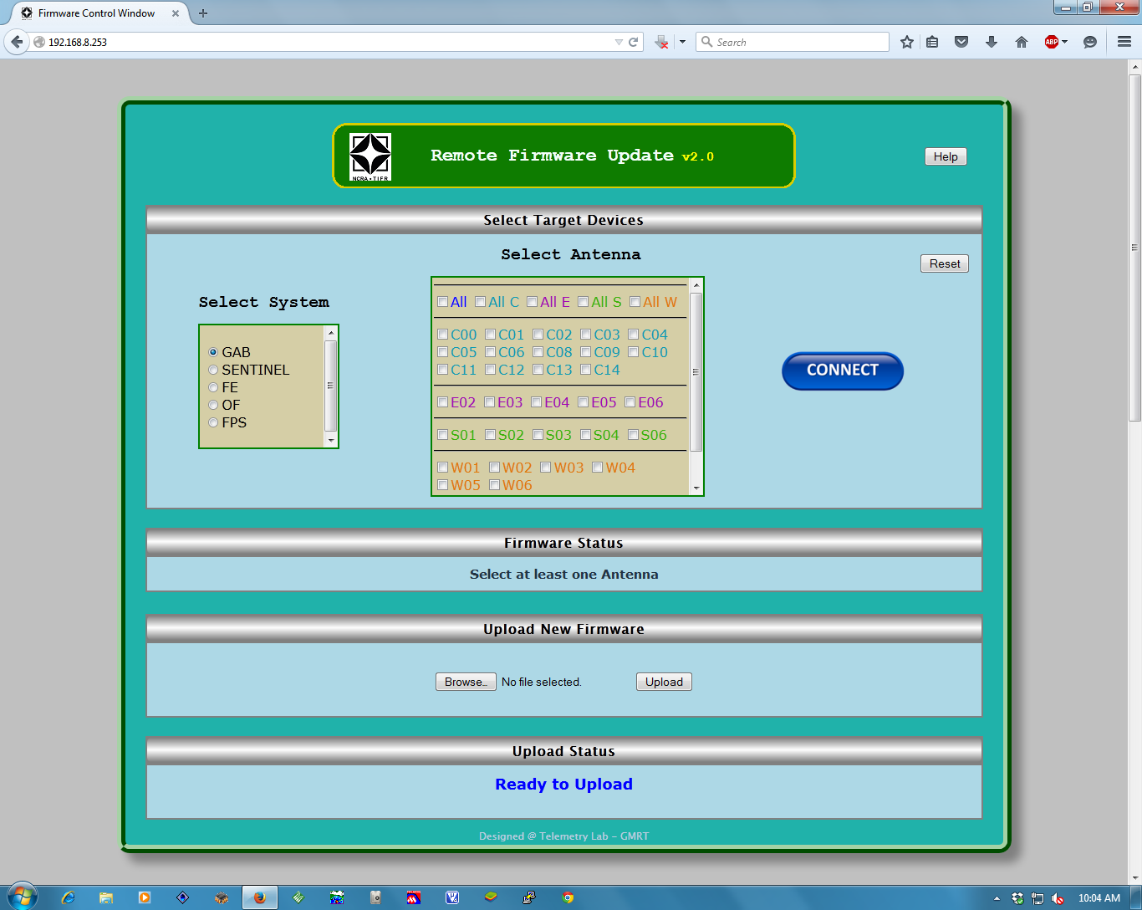

Figure 3.0: Webpage for Remote Firmware Update on multiple MCM cards.

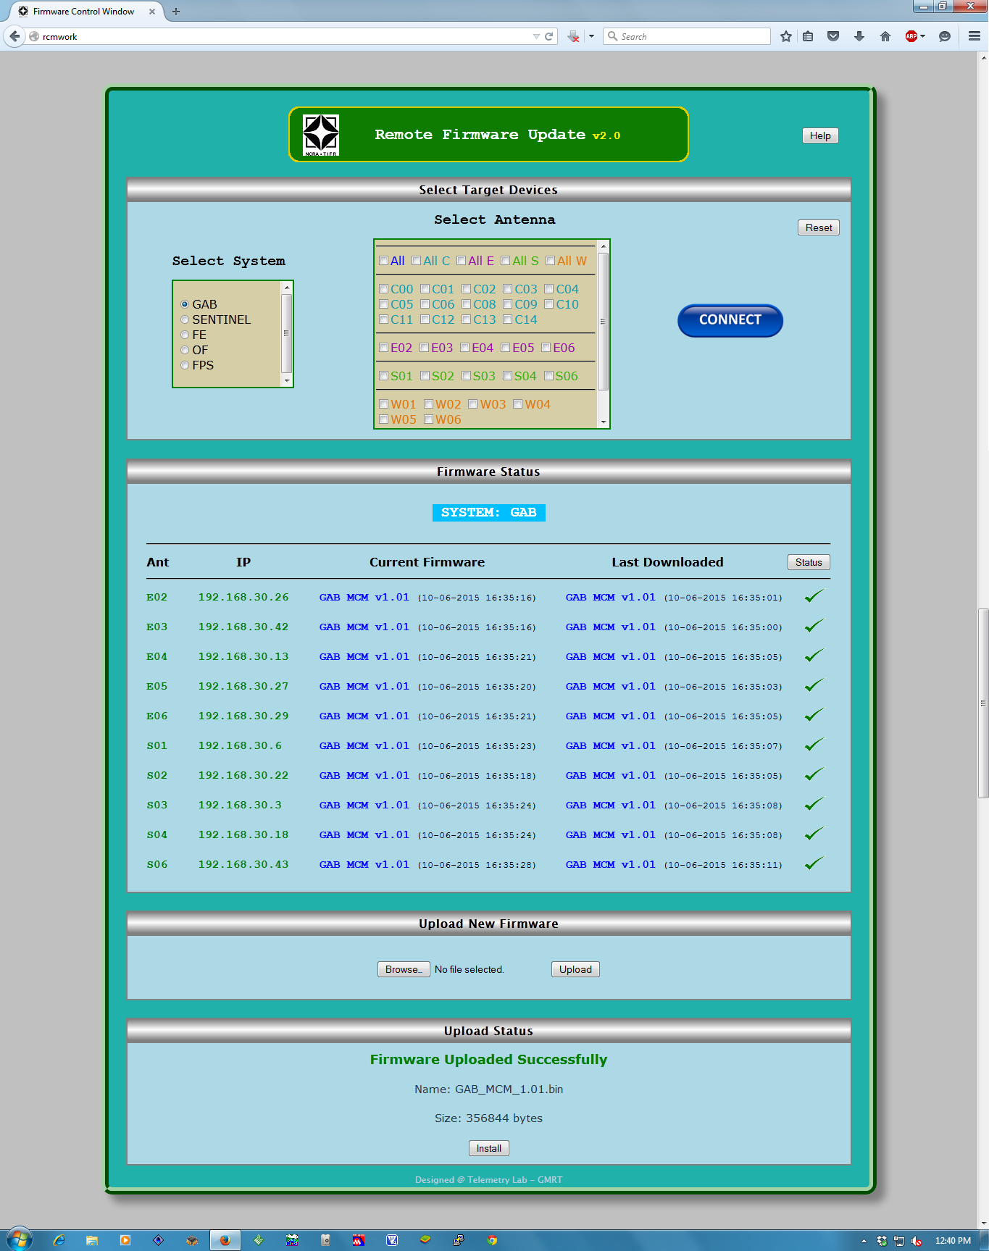

Step1: Enter Server IP address

Step3: Select Antennas

Step2: Select System address.

Step4: Click on Connect

Step5: Check Status

Step6: Upload firmware to server

Step7: Install Firmware

Figure 3.1: Firmware update process steps.

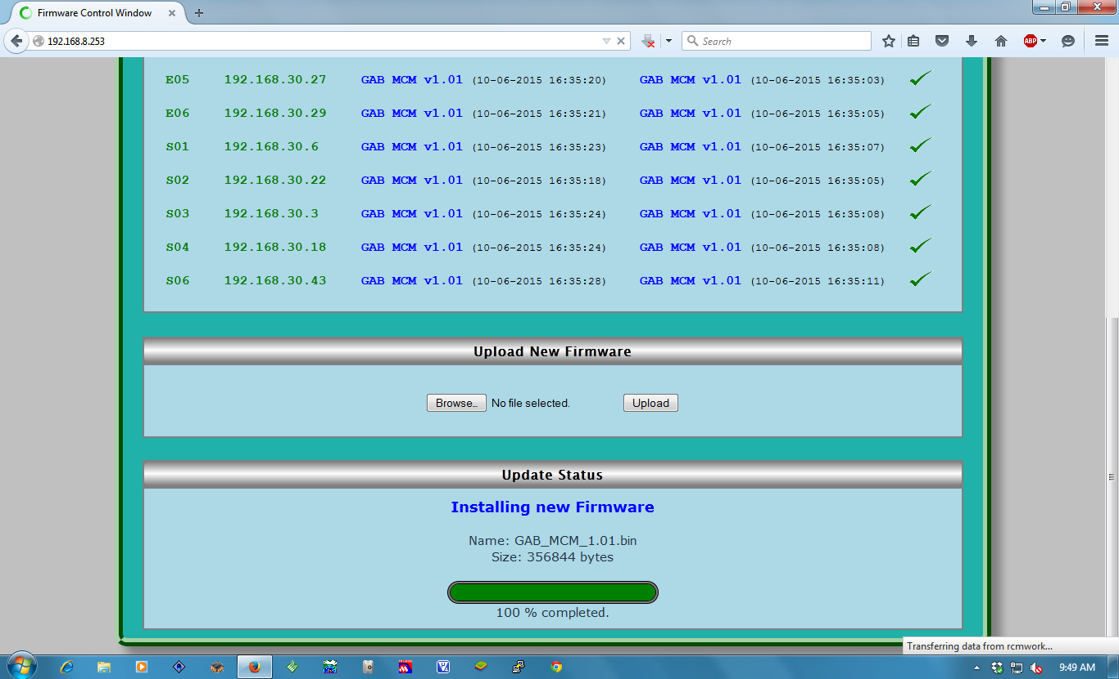

Figure 3.2: Firmware Installation progress.

**4. Remote Firmware Update From Linux Machine**

**Login host :** lmcuser@ngmnc(192.168.70.21)

***>/usr/local/gmrtSys/gab\_ctrl.sh TGC | ONL <space separated Antennas list in small letters>***

             // this upload GAB firmware of either TGC or ONL  for the mentioned antennas

             e.g. gab\_ctrl.sh ONL c00 c01 e02 e03

// This will restore firmware for the existing ONLINE system.

* gab\_ctrl.sh choose **'TGC'** (Tango Based GMRT Control System) option to use the TGC system, and to restore use **'ONL'** (Existing ONLINE System) option.

1. Files can be downloaded from the Windows server ***rcmwork*** machine using the link <http://rcmwork/rupdate> OR write email to rahul@gmrt.ncra.tifr.res.in [↑](#footnote-ref-1)